Gurjot Singh Nijjar

Application Report

I made a Simple Android Application based on the necessities of Hunter College. Hunter College has a huge directory of clubs that nobody seems to know about especially many Hunter Students. This app allows the user to access a database the clubs that are currently apart of Hunter Club. In my initial design I had planned to make this app be available as a means to get people search clubs but that was very inefficient because Hunter has many clubs but not that many that they can go through a list view where you can scroll down and access through. The List activity fetches Club information from the database and parses only the Club name and outputs on to the user interface.

Its available for the user to click on an individual Club and go to a new activity where it would go on to output the Club Name, Club information, and buttons to add any upcoming event to their calendar that is a part of the Android device and set a reminder and schedule the event in the calendar. The event is fetched from the database and streamed into the intent to parse the exact date and title of the event. The email button opens up the email application that is currently set to default and fetches the specific email from the database I created and puts that into the intent for the and opens up the built in Calendar app.

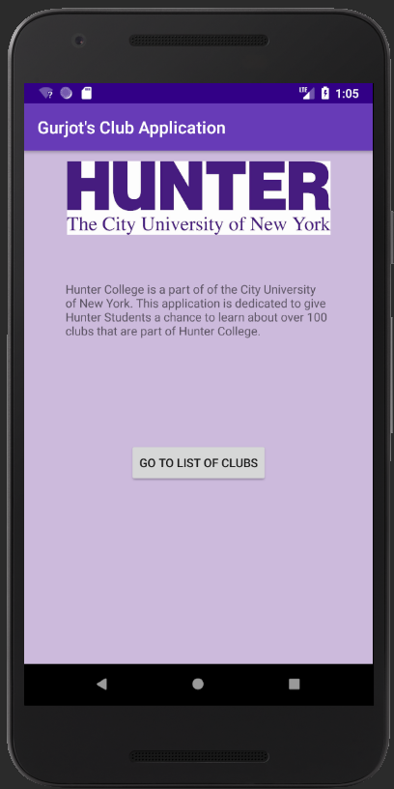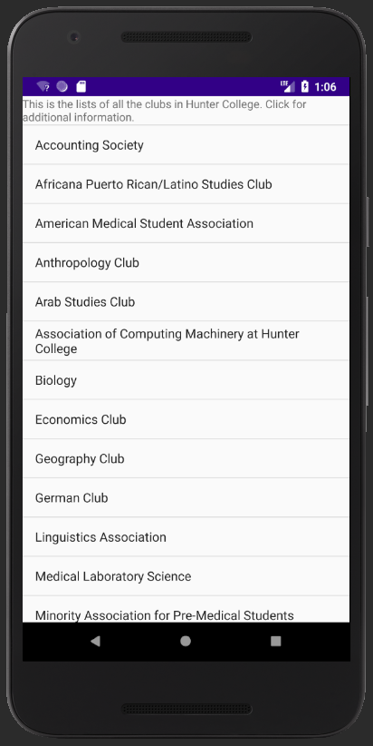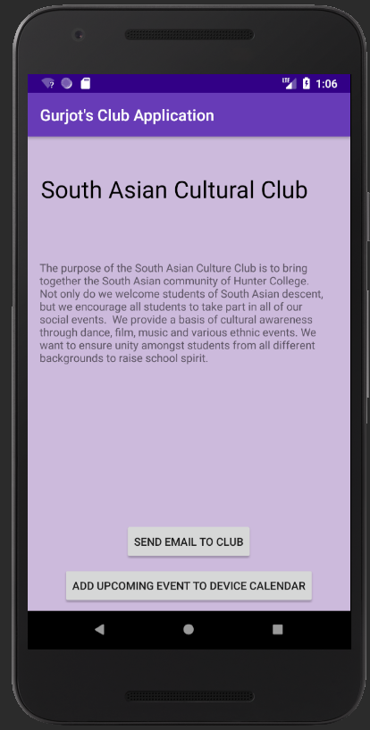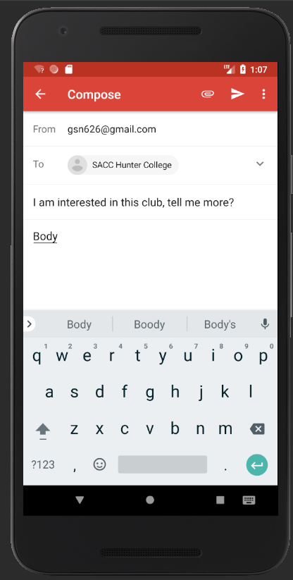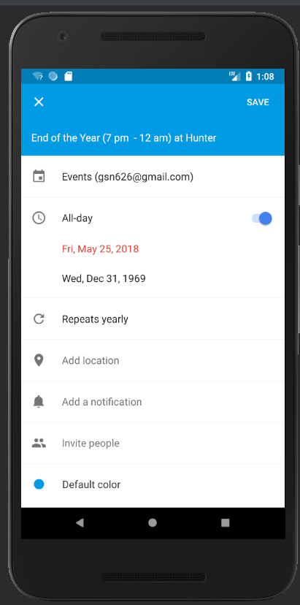 WIREFRAME IN ORDER

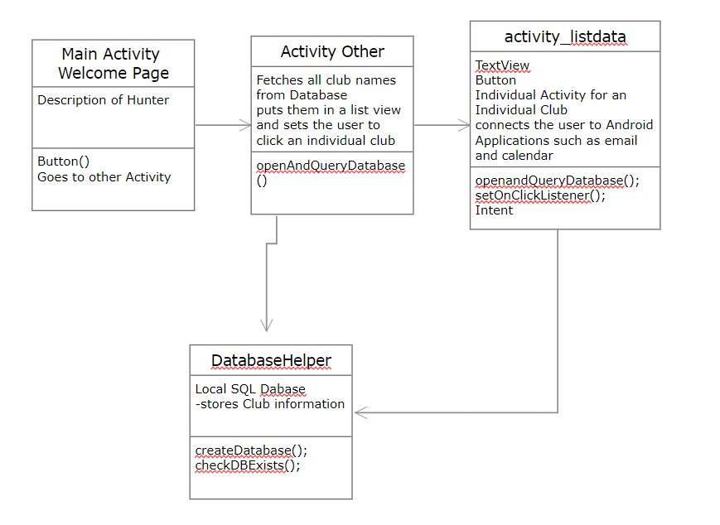

UML DIAGRAM